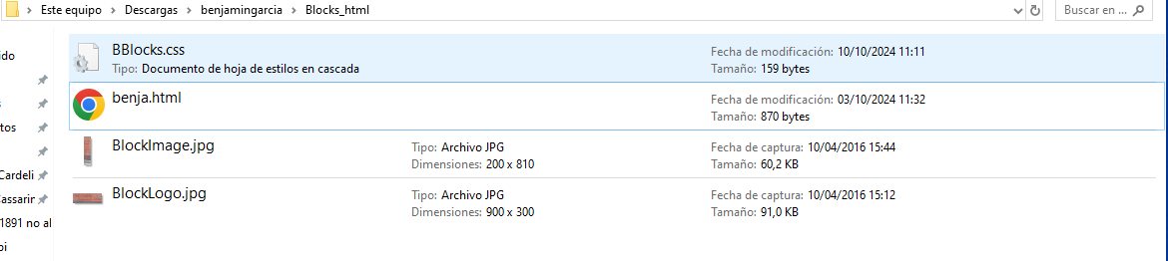

Evidence 5

the image does not mantain the aspect ratio